Autonomous Cars Nikesh Yadav and Deepak Shah

Introduction

Autonomous cars or self driving cars are cars that are capable of driving by themselves without any human engagement with driving controls. Autonomous cars don’t need any human input for driving rather they have an obstacle detection unit which includes sonar, stereo cameras, a localization camera, a laser, and a radar detection unit which work together to identify, track and predict the movements of pedestrians, bicycles, and other vehicles on the roadway. With the help from these sensors and the car’s built-in memory, it can identify “STOP” signs and traffic signals so that they can make necessary stops at a junction and prevent collisions.

Technology Behind Autonomous Cars

Autonomous cars generally use Bayesian Simultaneous Localization and Mapping (SLAM) algorithms, which fuse data from multiple sensors and an offline map into current location estimates and map updates. SLAM is a computational problem of construction or updating a map of an unknown environment while simultaneously keeping track of an agent’s location within it. They also use roadside RTLS (Real Time Locating System) beacons for localisation. They use sensors like lidar, stereo vision, GPS and IMU (Inertial Measurement Unit). Visual object recognition uses machine vision algorithms including neural networks.

How The Google Car Works

The Google self-driving car relies on a Light Detection and Ranging (LIDAR) system to provide it with a 360 degree view of what is around the vehicle. LIDAR is a remote sensing method that uses light in the form of a pulsed laser to measure ranges, or variable distances to Earth. These light pulses, combined with other data recorded by the system, generate precise, three-dimensional information about the shape of the Earth and its surface characteristics. The Google car is also equipped with external radar to provide direct velocity measurements. The LIDAR and radar combine with cameras, which are used to detect the color of traffic lights. The cameras also confirm what the car is detecting through the sensors. The car is also equipped with a GPS system. The car’s onboard computer uses data from the sensors to see objects as it navigates through a computer- generated 3D virtual environment, enabling it to avoid pedestrians or vehicles that unexpectedly cross its path.

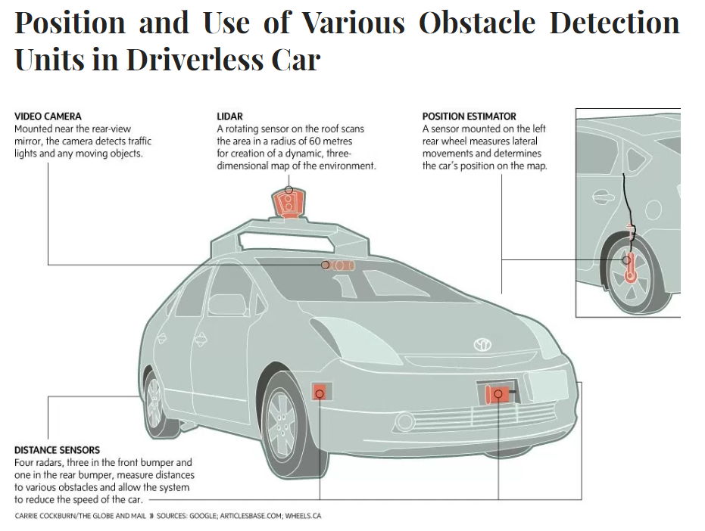

Advantages

The main advantage of autonomous cars is reduction in collision caused by errors of the drivers. Autonomous cars will reduce those collisions significantly because unlike humans they are not prone to errors caused by delayed reaction time and distraction. Consulting firm McKinsey & Company estimates that widespread use of autonomous vehicles could “eliminate 90% of all auto accidents in the United States, prevent up to US$190 billion in damages and health-costs annually and save thousands of lives”. Other advantages include higher speed limits, smoother rides, time saving and smoother traffic flow. There will be less need of traffic police and vehicle insurance. Autonomous cars could be highly beneficial for children, elderly and disabled since these people won’t need to to drive the car by themselves.

Potential Obstacles

One of the main concerns about autonomous cars is people having to put their life completely in the hands of computers because even a small software bug or incompatibility might take their life. The car’s sensing and navigation systems might be susceptible to different types of weather or interference. While autonomous cars are going to improve the economy in long term, it will likely have negative effects in short term. It will eliminate jobs like taxi drivers and normal car companies may get out of business. Additionally, it will be expensive - “The price of a new F-150 is just over 70 grand” (Zero to 60) and hence unaffordable by citizens of poor countries. As the cars will depend on GPS technology, it might not work properly in some countries. And there will certainly be hackers trying to access these cars from remote locations.

Industrial Progress

Google’s self driving car project called Waymo, started in 2009. By 2012, the cars traveled 300,000 miles without a driver even in complex city streets. In 2014, a new prototype vehicle was designed which had custom sensors, computers, steering and braking, but no steering wheels or pedals. And finally by 2016, the world’s first fully self-driving cars drove over 2 million miles on public roads with no driver. Besides Google, Tesla has been also putting enormous amount of work in autonomous cars. Starting October 2016, all Tesla cars are built with the necessary hardware to allow full self-driving capability. The system will be operating in “shadow mode” where no action will be performed but the data will be sent to Tesla to improve its abilities until the software is ready for deployment. After the required testing, Tesla expects to enable full self-driving by the end of 2017. On 16th August, 2016 Ford announced its intent to have a high-volume, fully autonomous vehicles in commercial operation by 2021. “The next decade will be defined by automation of the automobile, and we see autonomous vehicles as having as significant an impact on society as Ford’s moving assembly line did 100 years ago”, said Mark Fields, Ford president and CEO.

References

"Google Driverless Car- The Obstacle Detection Unit." *What A Future!!* N.p., 28 Dec. 2016. Web. 12 Feb. 2017

"Google Driverless Car – Under the Hood of the Car." *The Future of Technology*. N.p., 16 June 2014. Web. 12 Feb. 2017

"The What, How, and Why of Artificial Intelligence, Machine Learning, and Self-Driving Cars." *Udacity*. N.p., 10 Nov. 2016. Web. 12 Feb. 2017

"Waymo." *Waymo*. N.p., n.d. Web. 12 Feb. 2017.

Summary: Biometrics Of The Fingerprint Recognition

Fingerprint scanner is one of the prevalent biometric security used in technology products today. When a user asks permission to be authenticated into a system, a fingerprint sample is taken and is sent to the database to be verified. Before the sample can be compared, the fingerprint undergoes training phase where a system is trained from the actual fingerprints of the owner. The system learns the distinctive features based on image pattern recognition and later when it receives a new test fingerprint, it can compare from the database to decide whether to give access or not. The advancement in this field is based on three main patterns of fingerprint identified as Arch, Loop and Whorl. The major algorithmic advancements in fingerprint scanning took place between 2001 and 2012. In 2001, some university students presented a new fingerprint classification algorithm based on Support Vector Machine and Recursive Neural Networks. In 2012, couple of students in Greece presented a multimodal of four machine learning algorithms from fusion of several biometrics modalities that included Gaussian Mixture Models (GMMs), Artificial Neural Networks (ANNs), Fuzzy Expert Systems (FESs) and Support Vector Machines (SVMs). The market for fingerprint identification system is huge. This sector was valued at $5 billion in 2012, nearly $10 billion in 2015 and it is estimated to reach a worth of $32.73 billion in 2022. Despite the long history of using fingerprints, some key concerns still remain about the accuracy of identification, the usability of fingerprint systems in different situations, acceptance by the users and other privacy concerns.